Hawaiian Pineapple Chicken
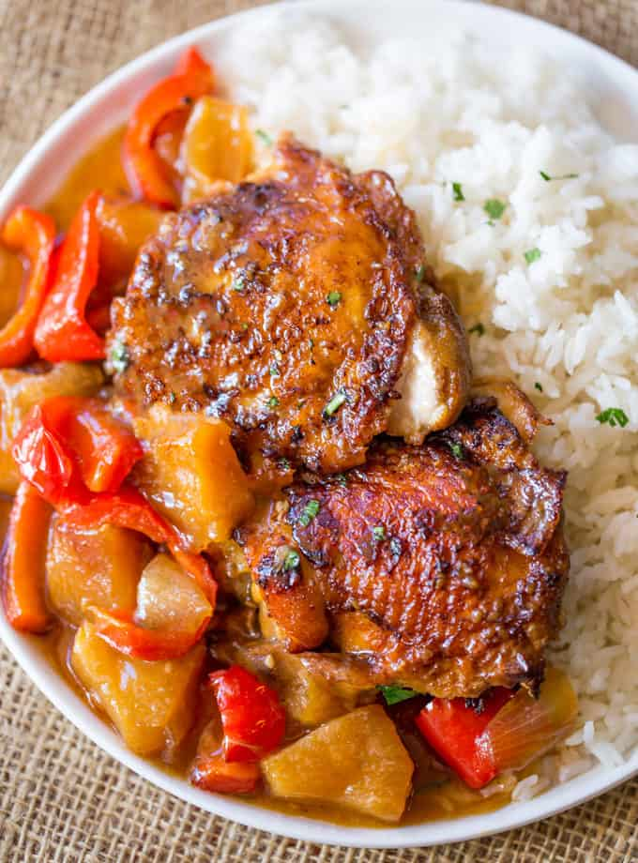
Prep time 5 min Cook time 30 min
2 Servings
Ingredients
1 cup pineapple, cut into 1" chunks
½ yellow onion, chopped
1½ tbsp honey
1 tbsp soy sauce
¼ cup dark brown sugar
½ tbsp grated ginger
1 garlic clove, minced
1 tsp sesame seeds (optional)
½ tbsp cornstarch
Directions
- Preheat the oven to 350 degrees.
- Mix all the ingredients together except the cornstarch in a large bowl.
- Line the bottom of a baking dish with a thin layer of sauce.
- Place chicken in the baking dish, then cover with remaining sauce. Cook uncovered for 30 minutes.
- Add the cornstarch to a tablespoon of water, mix, and add to the baking dish. Cook for an additional 10 minutes.
- Serve over rice.

